**COMPONENT ANALYSIS ON SOFT SKILLS OF PROSPECTIVE EMPLOYEES**

**Component – Concentrate Analysis of Candidates**

**Project ID - TMP-2023-24-128**

**Status Document 01**

**Premathilaka M.A.D.M**

**IT20624330**

**B.Sc. (Hons) Degree in Information Technology Specialized in Information Technology**

**Faculty of Computing**

**Sri Lanka Institute of Information Technology**

**Sri Lanka**

**November 2023**

**COMPONENT ANALYSIS ON SOFT SKILLS OF PROSPECTIVE EMPLOYEES**

**Component – Concentrate Analysis of Candidates**

**Project ID - TMP-2023-24-128**

**Status Document 01**

**Premathilaka M.A.D.M**

**IT20624330**

**B.Sc. (Hons) Degree in Information Technology Specialized in Information Technology**

**Faculty of Computing**

**Sri Lanka Institute of Information Technology**

**Sri Lanka**

**November 2023**

# Declaration page of the candidates & supervisor

I declare that this is our own work, and this proposal does not incorporate without acknowledgement any material previously submitted for a degree or diploma in any other university or Institute of higher learning and to the best of our knowledge and belief it does not contain any material previously published or written by another person except where the acknowledgement is made in the text.

|  |  |  |
| --- | --- | --- |
| Name | IT Number | Signature |
| Premathilaka M.A.D.M | IT20624330 |  |

Signature of the Supervisor Date

(Dr. Shanta Yapa)

**Table of Contents**

Declaration page of the Candidate and the supervisor

1. Screenshots of Mails

* Figure 01: Request for Research Project Supervision
* Figure 02: Supervision Acceptance Mail
* Figure 03: Mail for Research Topic Idea discussion
* Figure 04: Meeting Request Mails
* Figure 05: Physical/ Online meetings with Supervisor, Co-Supervisor, External Supervisor schedules via mails
* Figure 06: Send Research Related Documents via Mails
* Figure 07: Research Paper Related Mails

1. Screenshot of Azure Board

* Figure 01: Azure Board
* Figure 02: Azure Grid
* Figure 03: Azure Charts

1. Screenshot of Git Repository

* Figure 01: GitHub my Branch
* Figure 02: GitHub my Branch Readme file

1. Screenshot of Zoom Online Meetings
2. Screenshot of Microsoft Teams Task Board
3. Screenshot of WhatsApp Chat

* Figure 01: WhatsApp Chat with Supervisor
* Figure 02: WhatsApp Chat with Co-Supervisor
* Figure 03: WhatsApp Group Chat with Co-Supervisor

1. Gantt Chart
2. Work Breakdown Structure

# Screenshots of Mails

## Figure 01: Request for Research Project Supervision

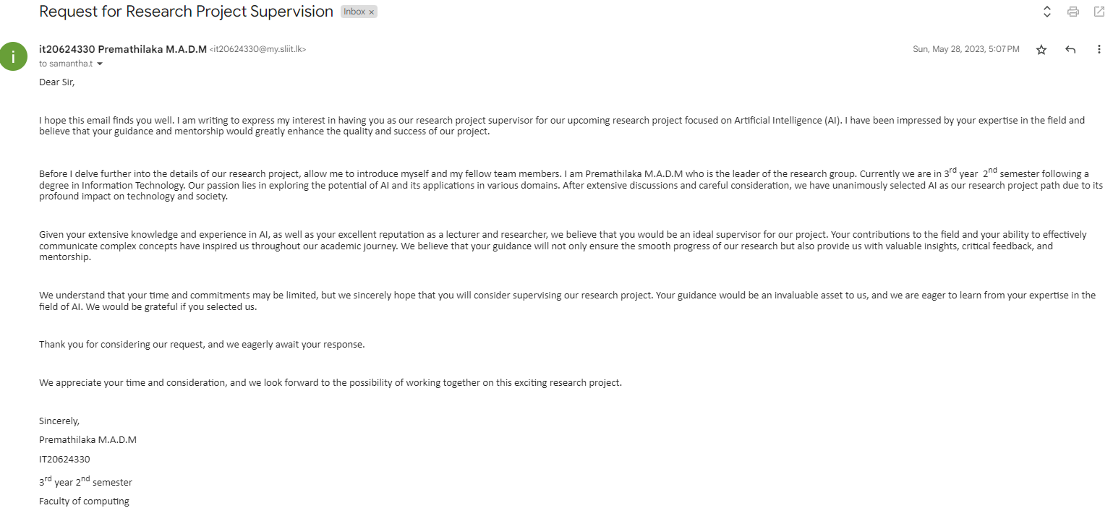

## Figure 02: Supervision Acceptance Mail

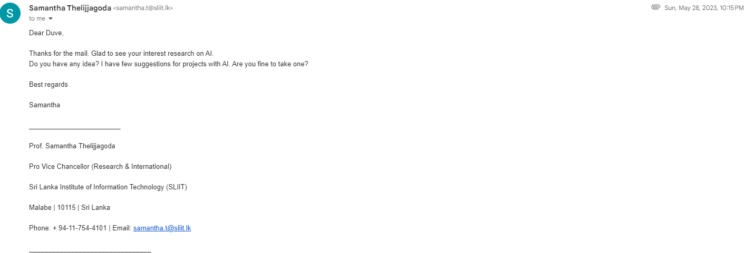

## Figure 03: Mail for Research Topic Idea discussion

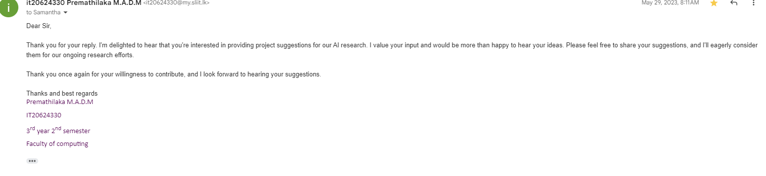

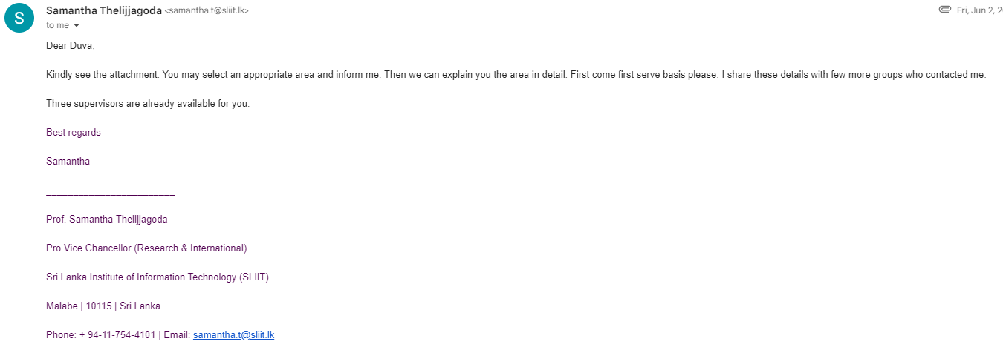

## Figure 04: Meeting Request Mails

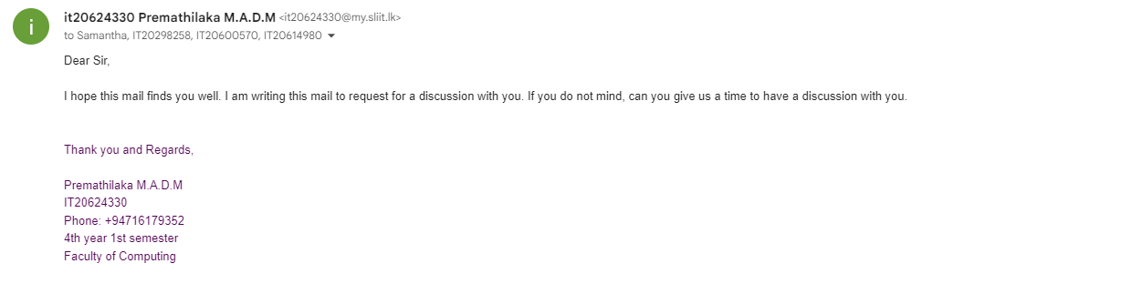

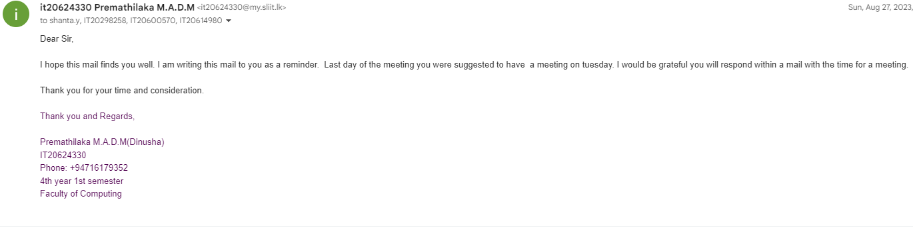

## Figure 05: Physical/ Online meetings with Supervisor, Co-Supervisor, External Supervisor schedules via mails





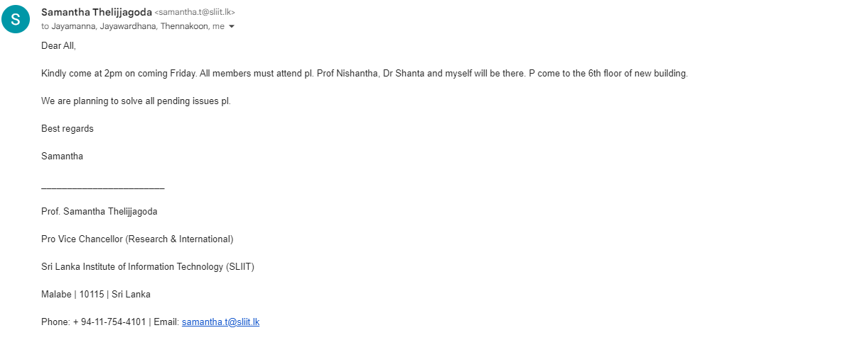

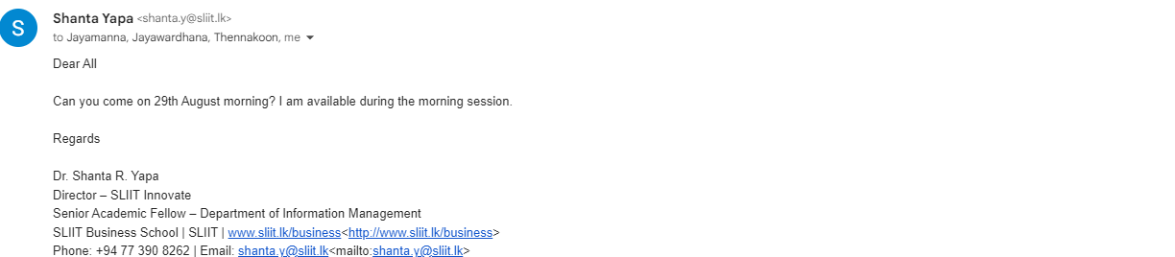

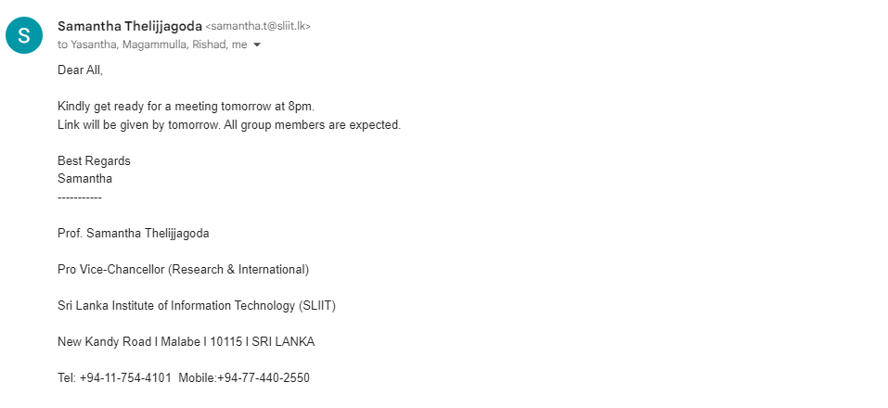

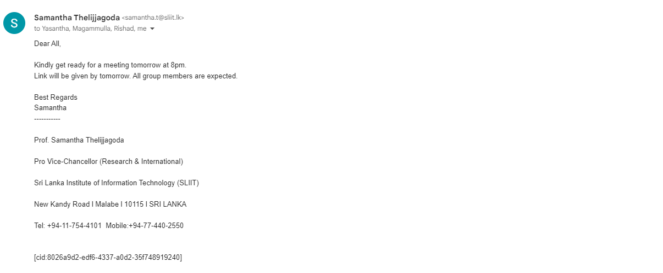

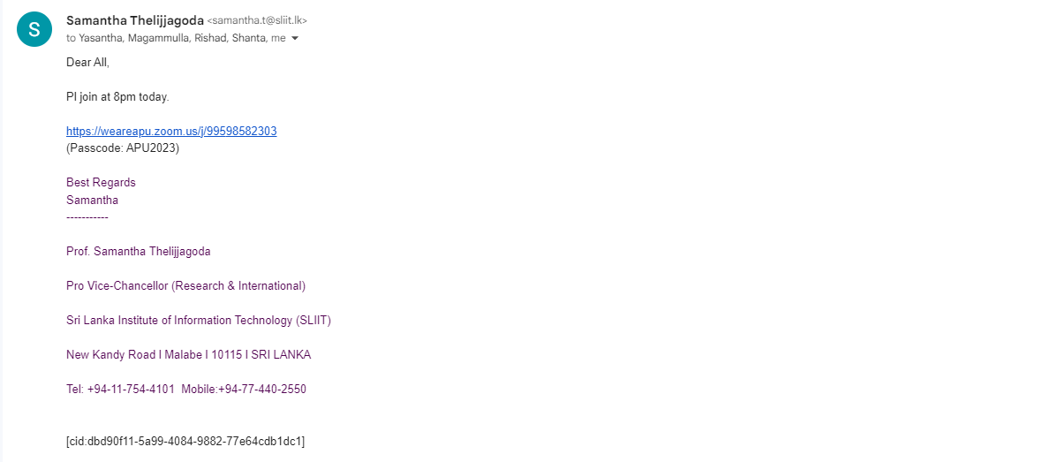



## Figure 06: Send Research Related Documents via Mails

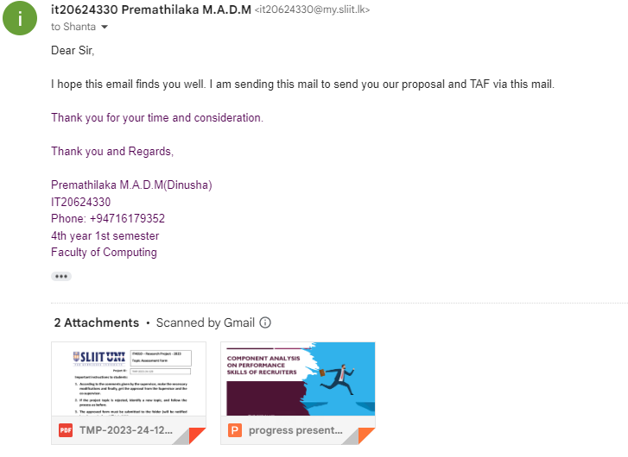

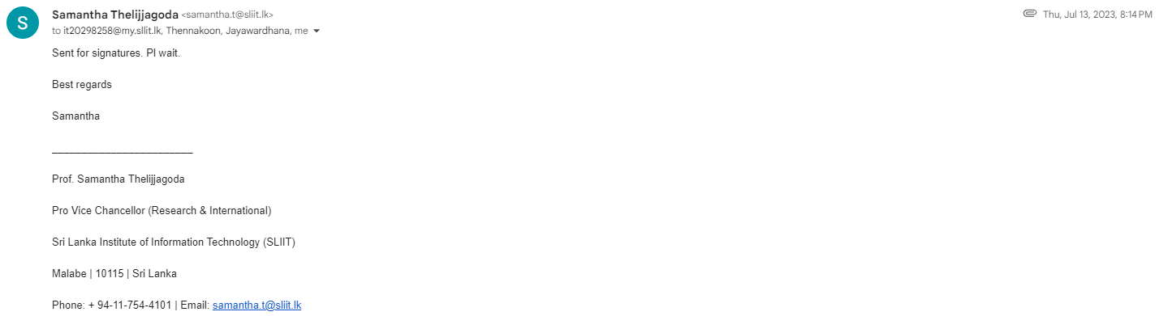

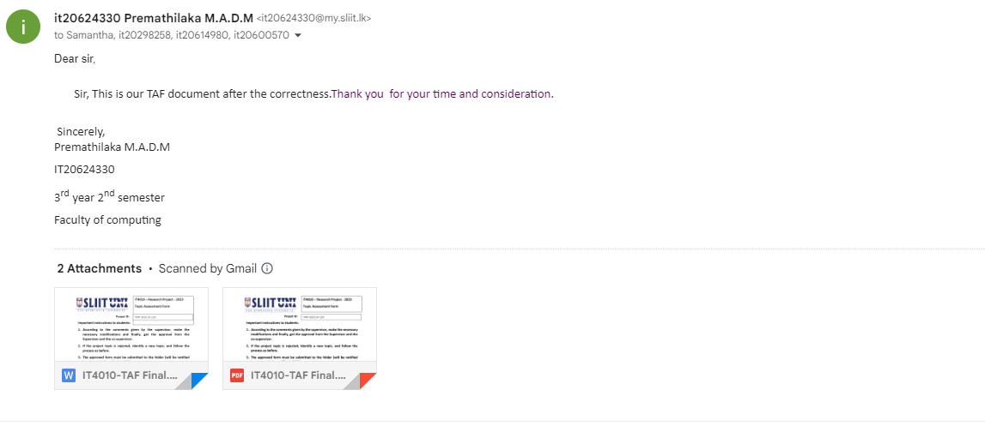

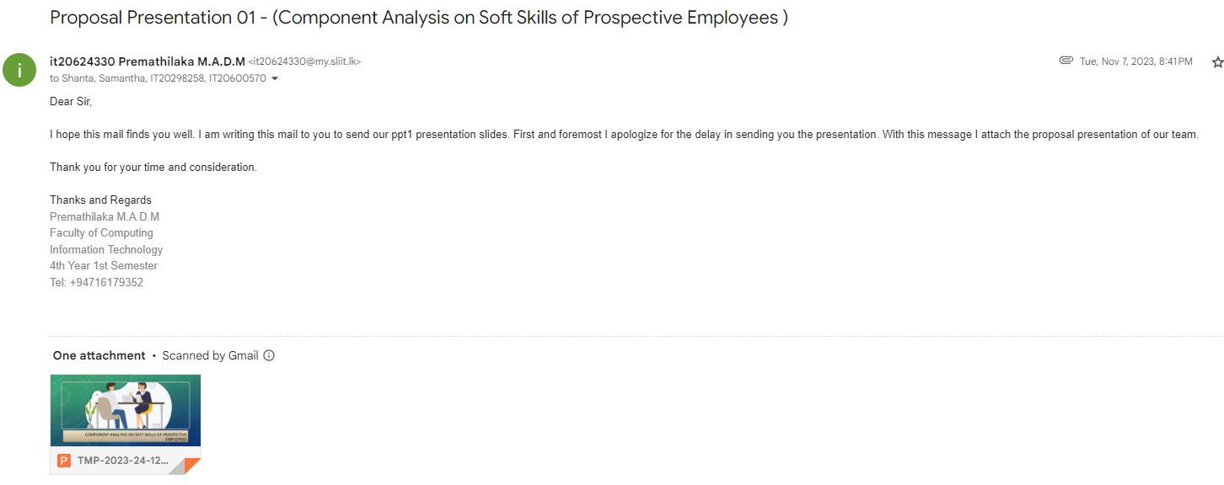

## Figure 07: Research Paper Related Mails

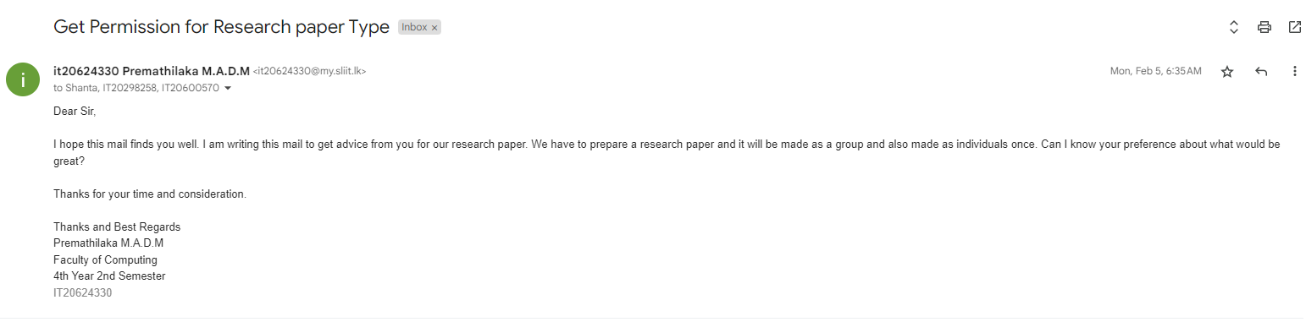

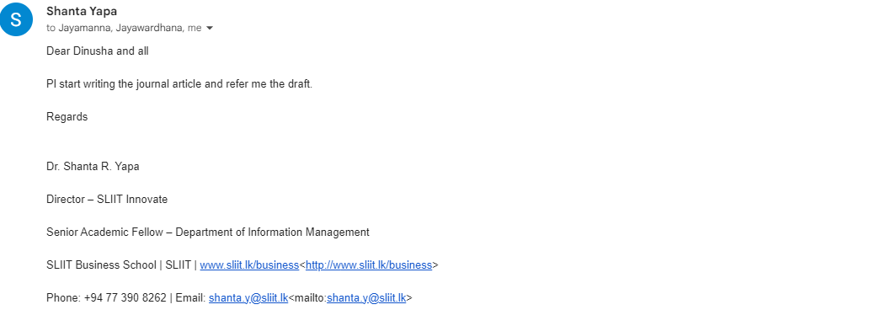

# Screenshot of Azure Board

## Figure 01: Azure Board

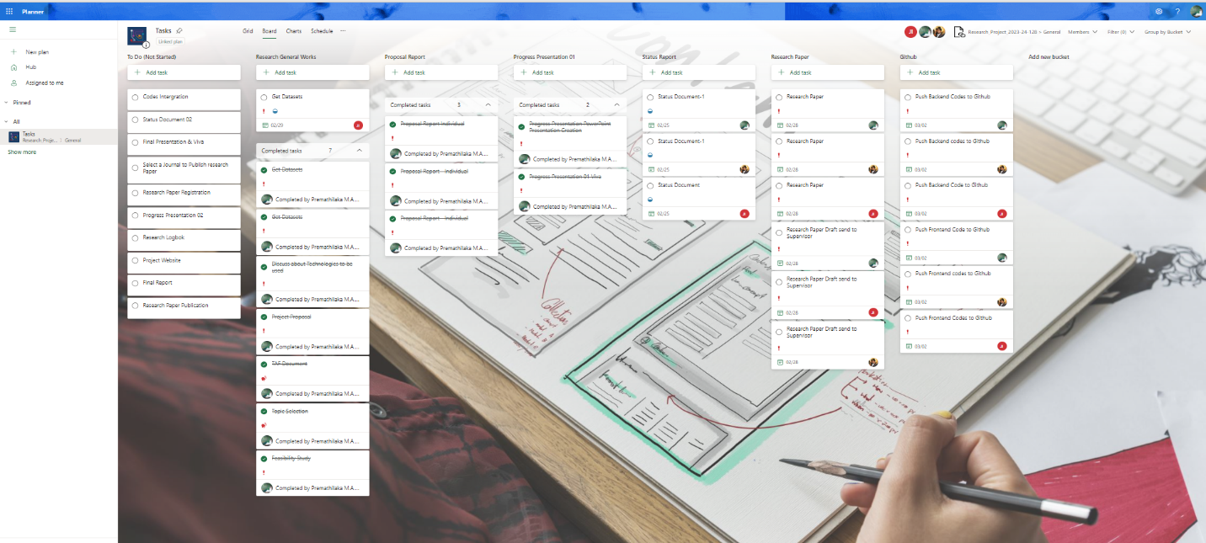

## Figure 02: Azure Grid

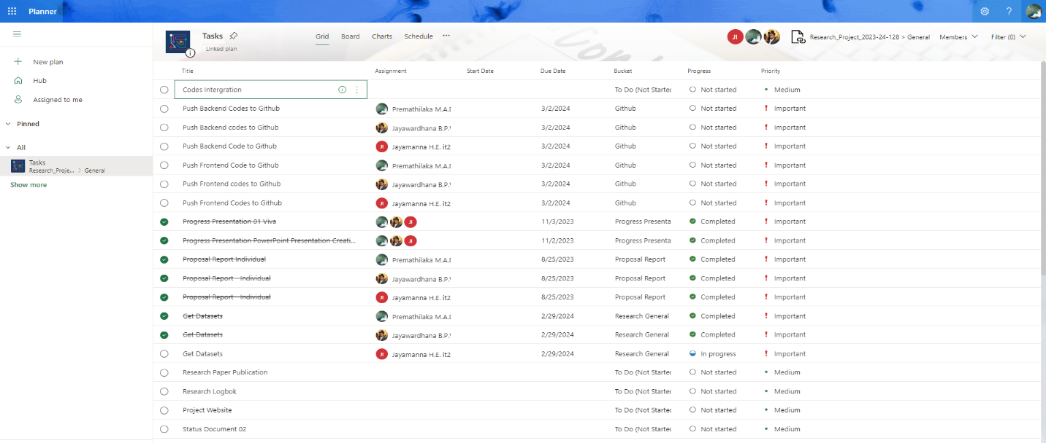

## Figure 03: Azure Charts

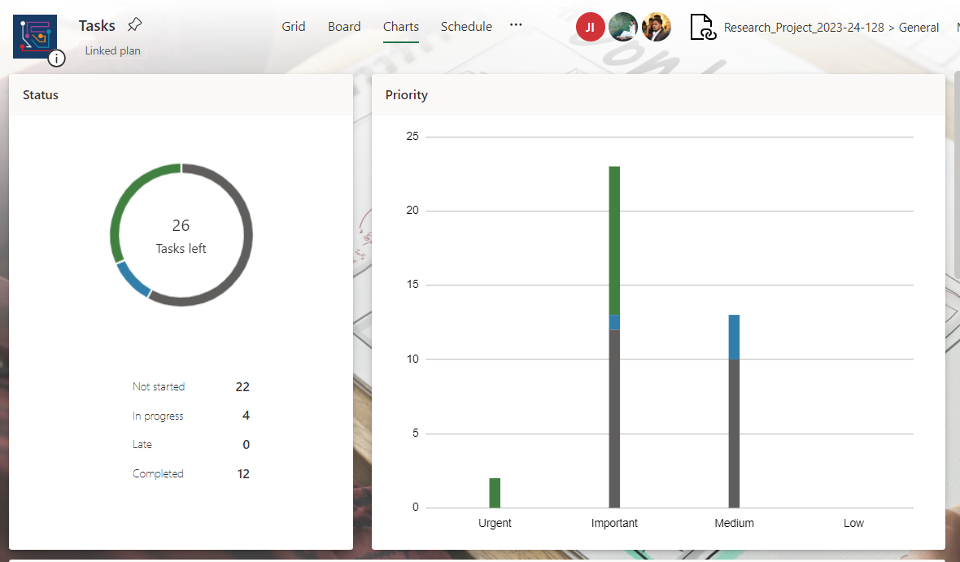

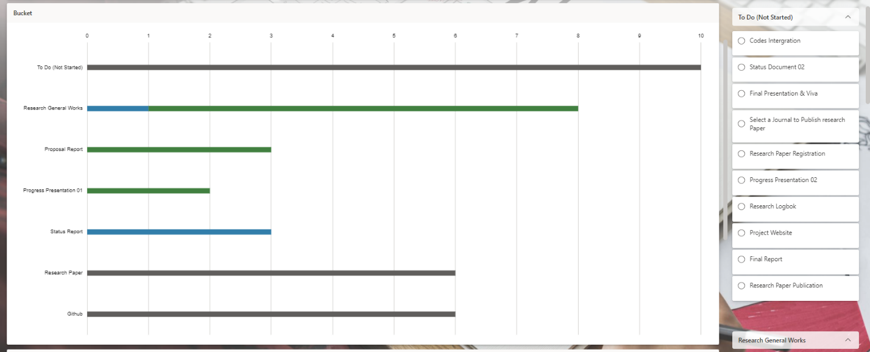

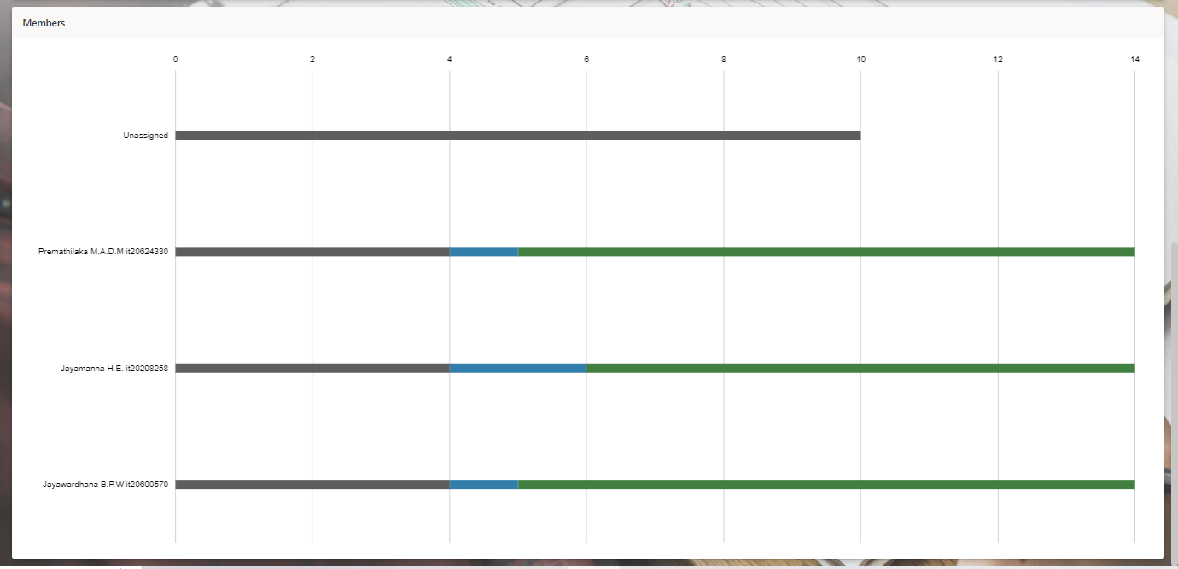

# Screenshot of Git Repository

## Figure 01: GitHub my Branch

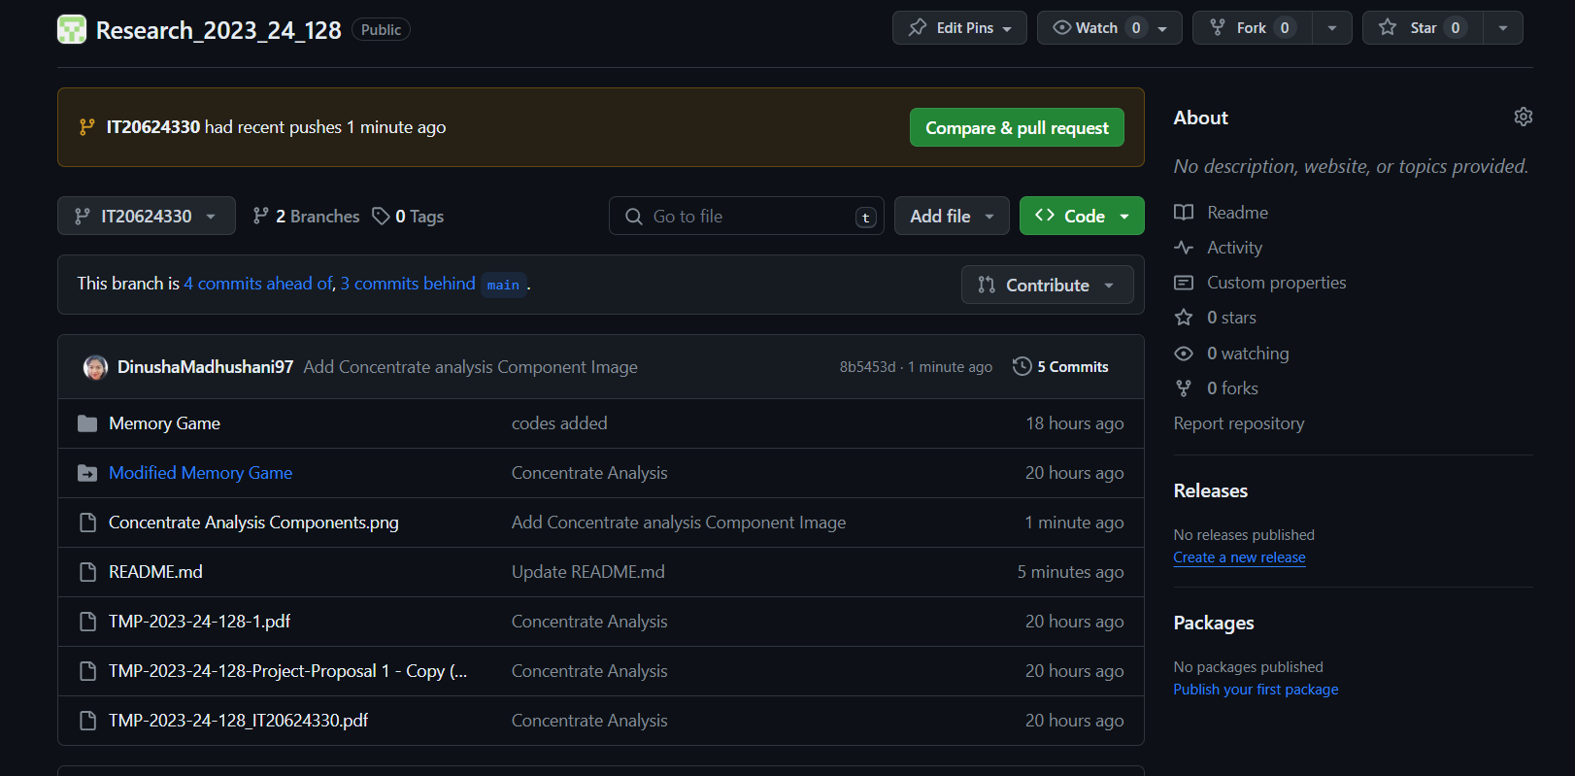

## Figure 02: GitHub my Branch Readme file

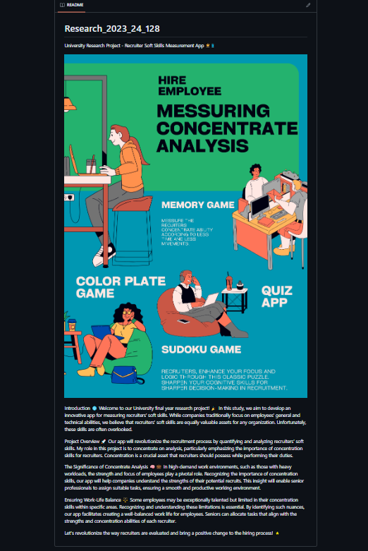

# Screenshot of Zoom Online Meetings

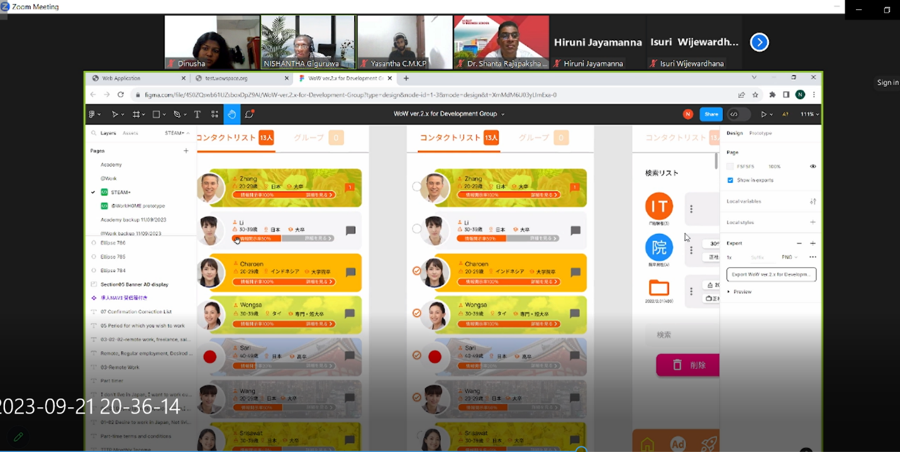

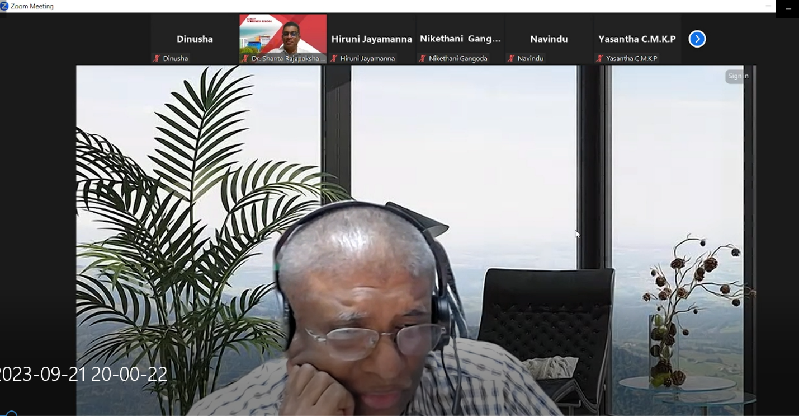

# Screenshot of Microsoft Teams Task Board

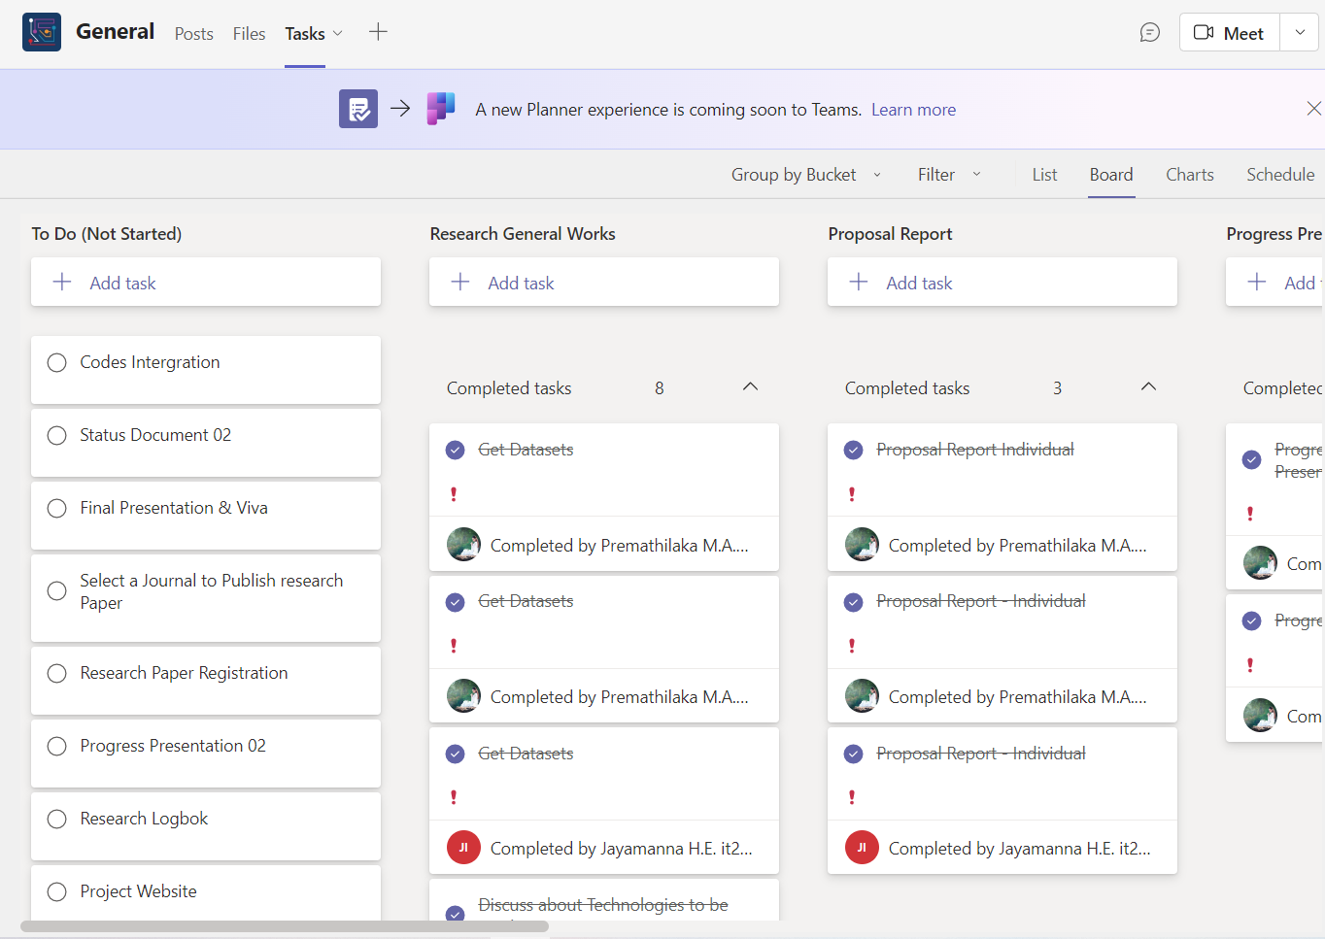

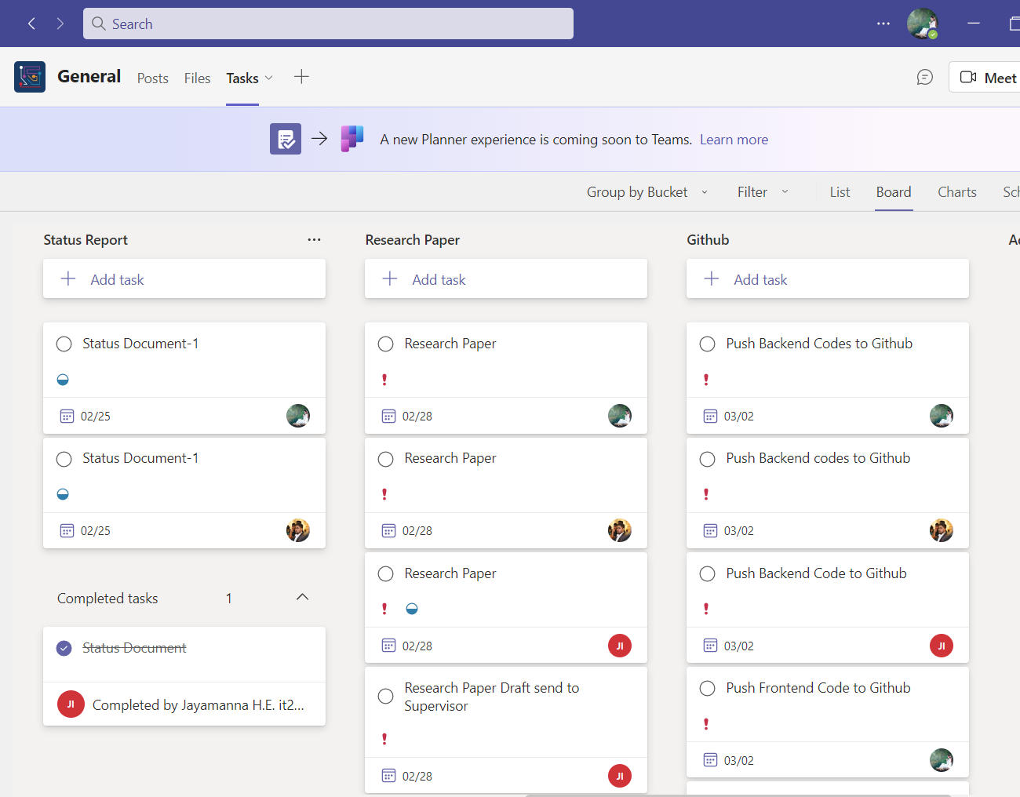

# Screenshots of WhatsApp Chats

## Figure 01: Chats with Supervisor

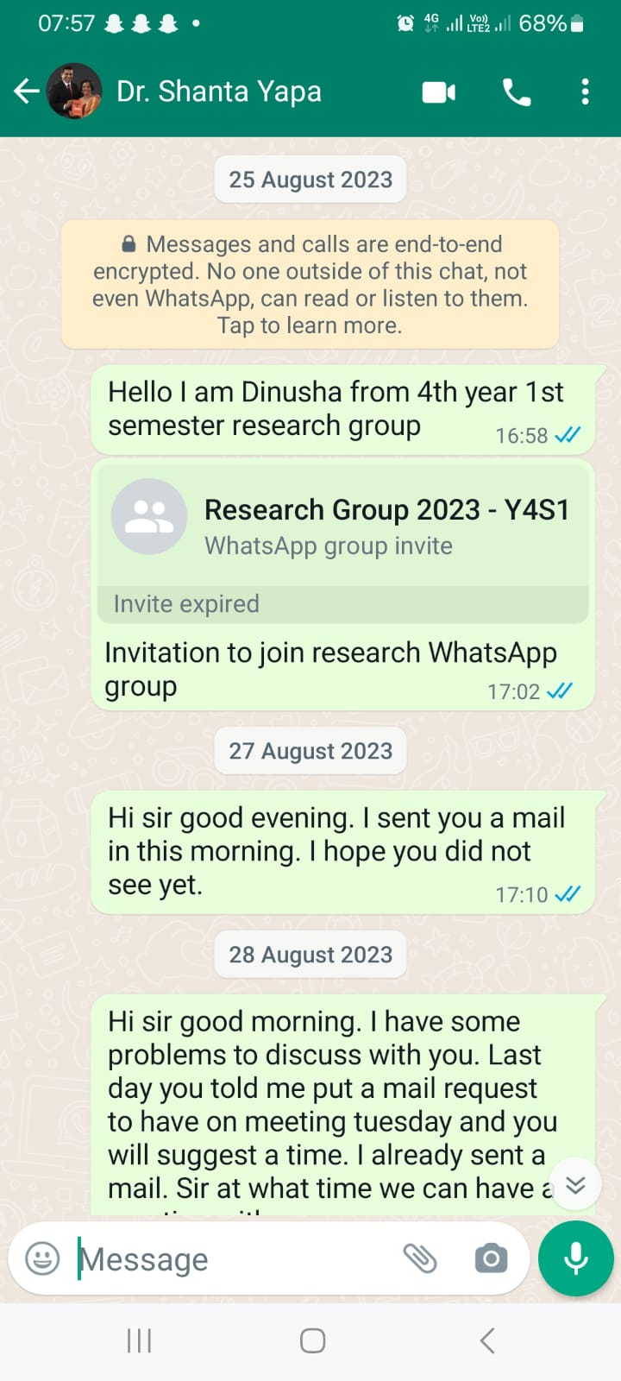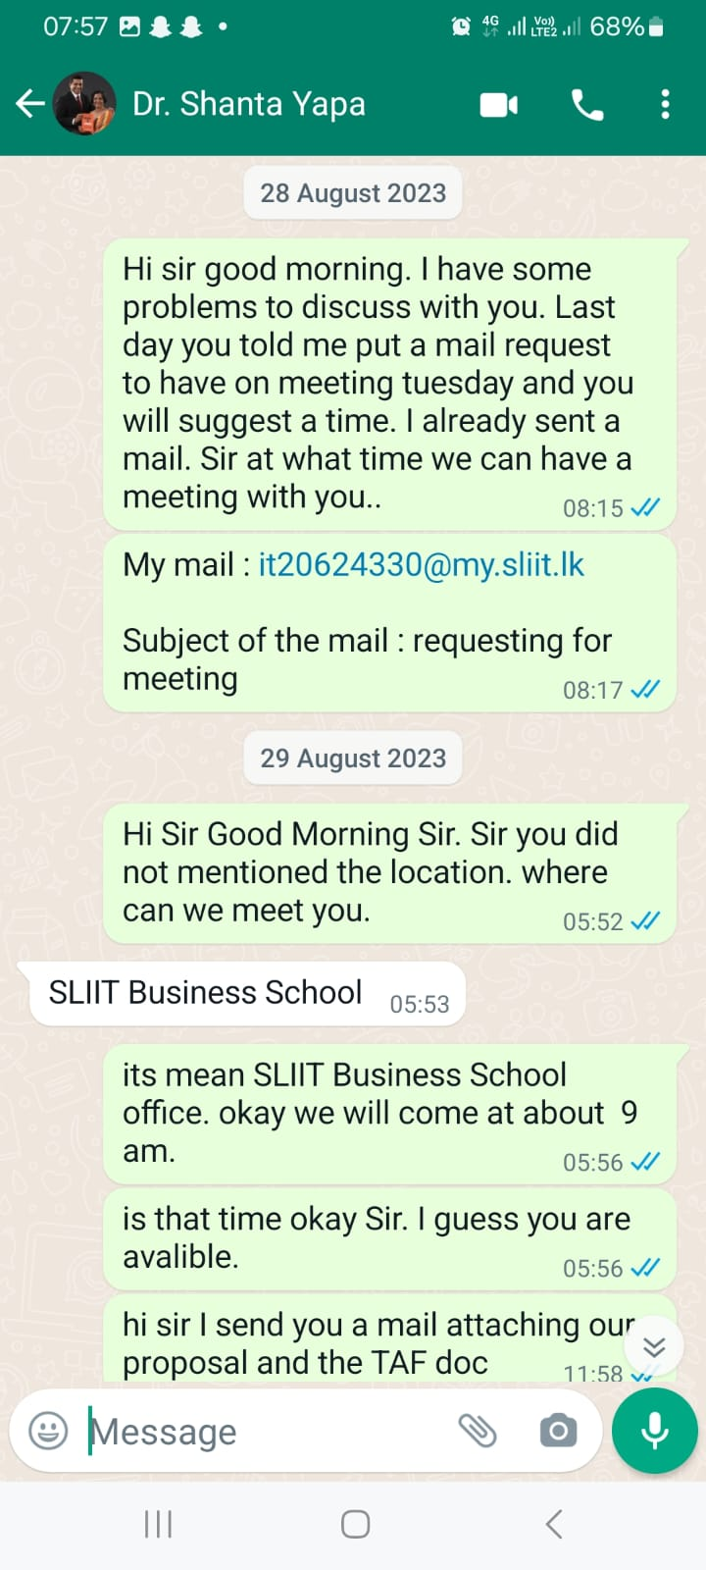

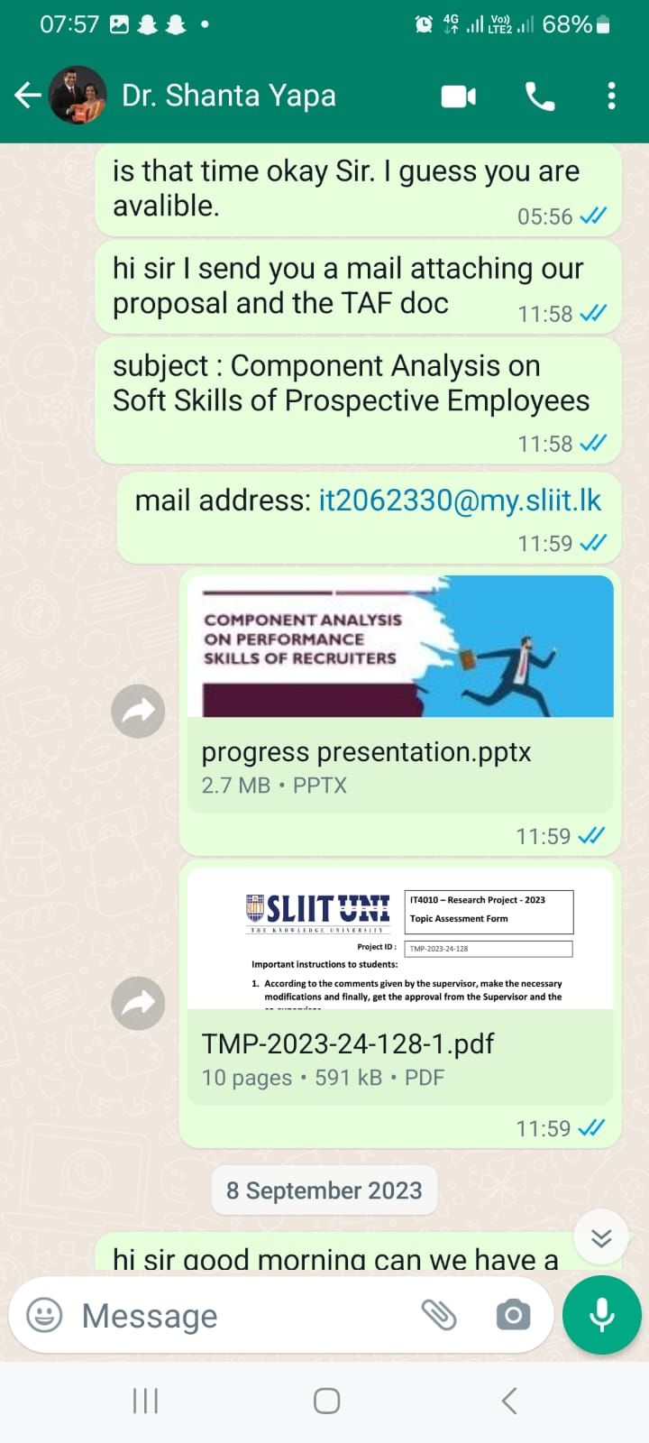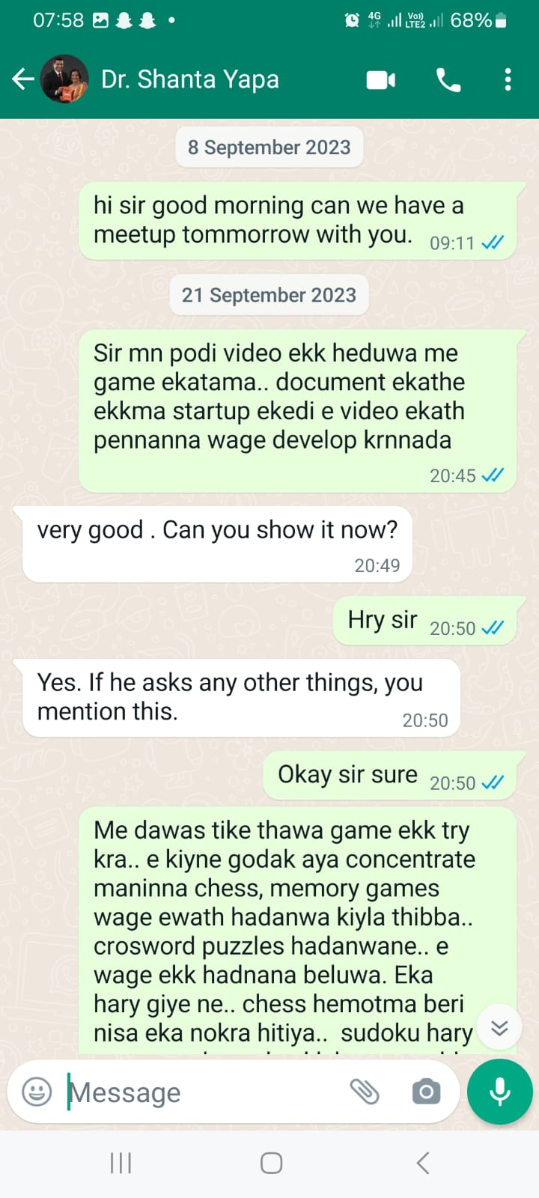

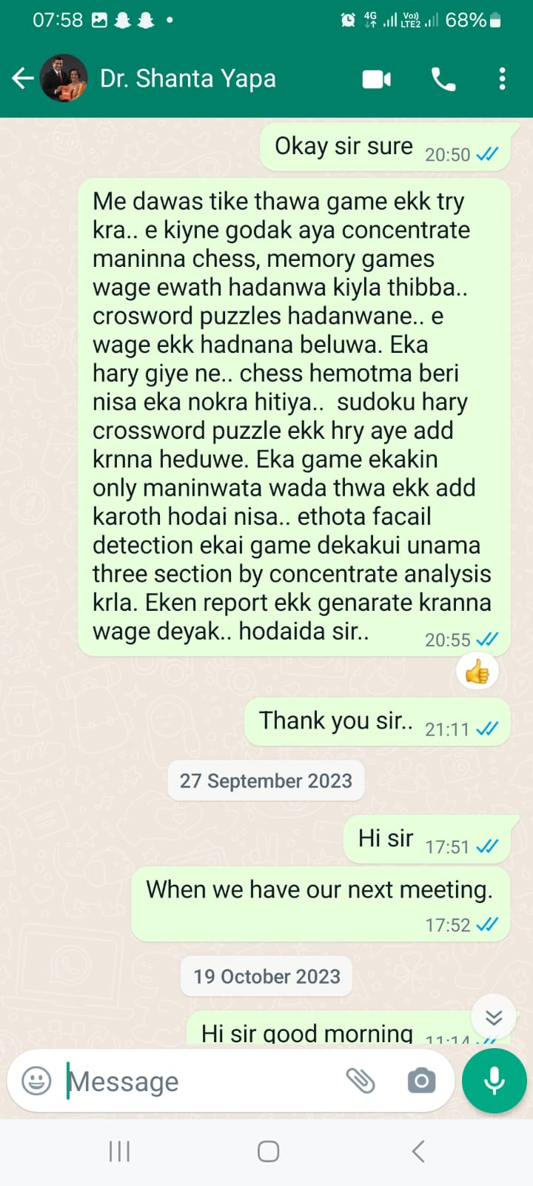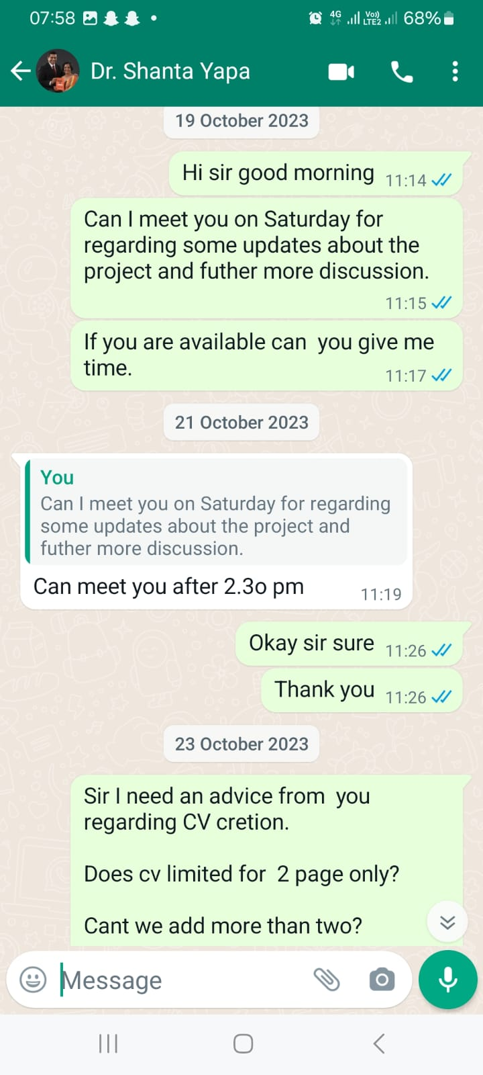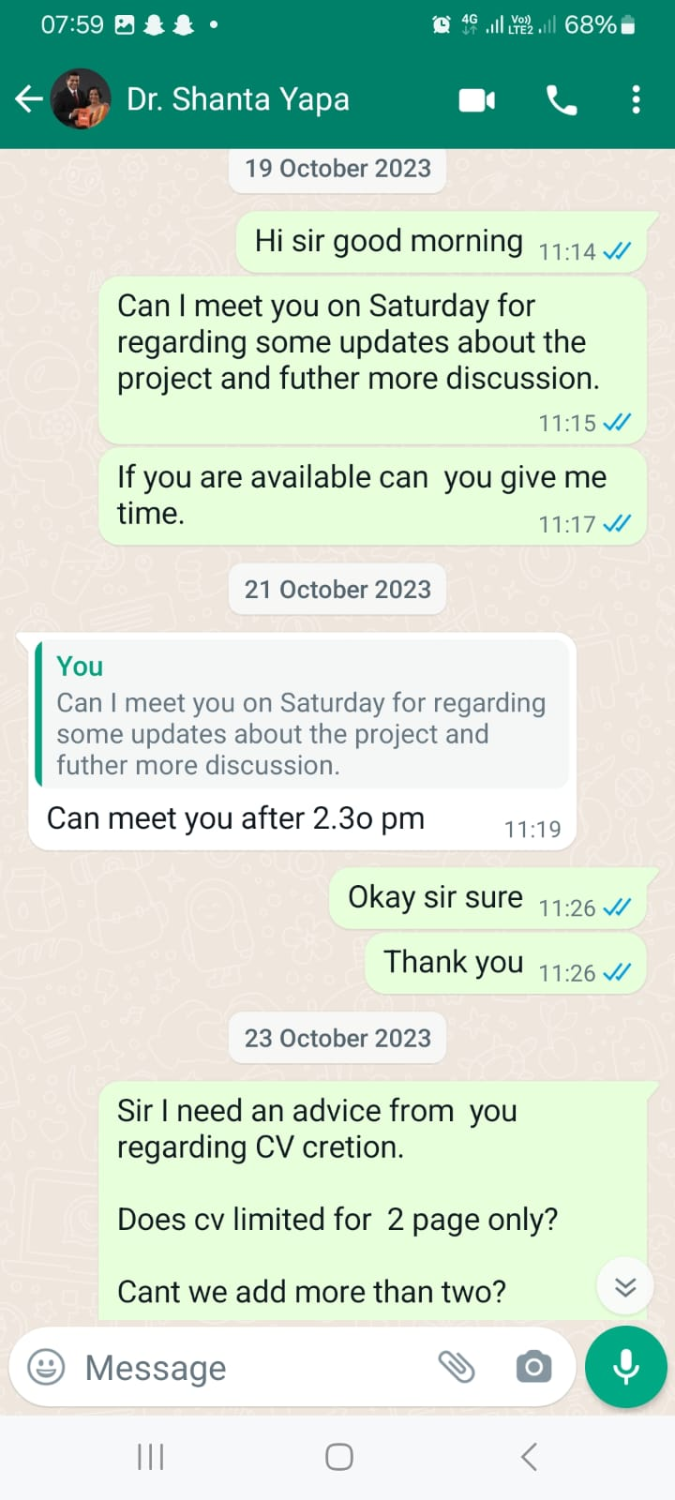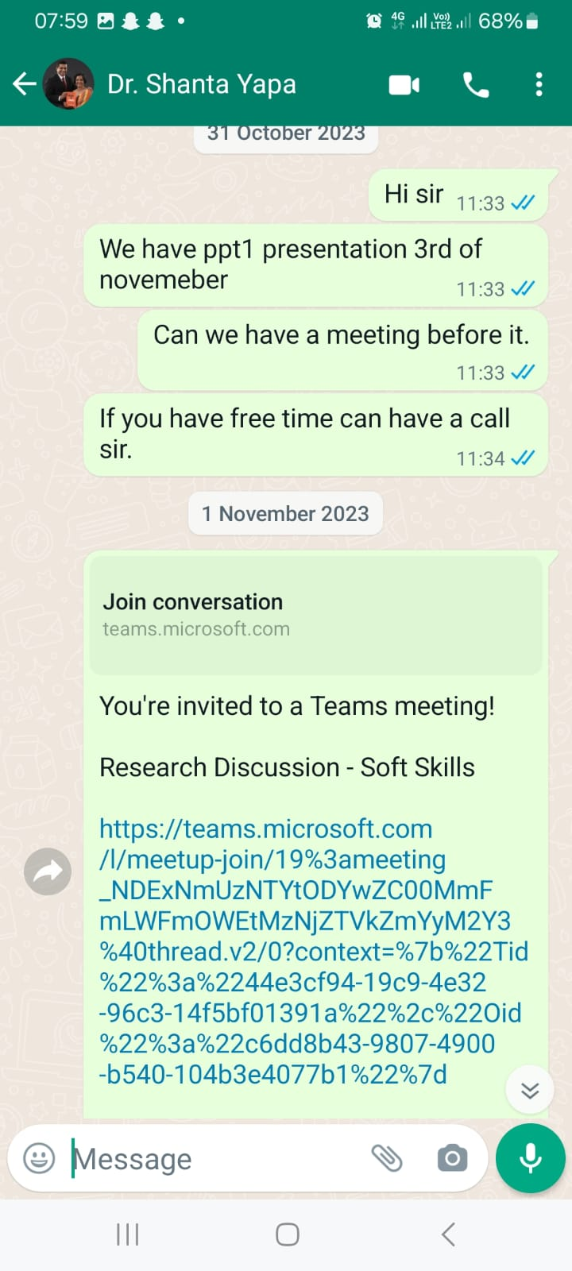

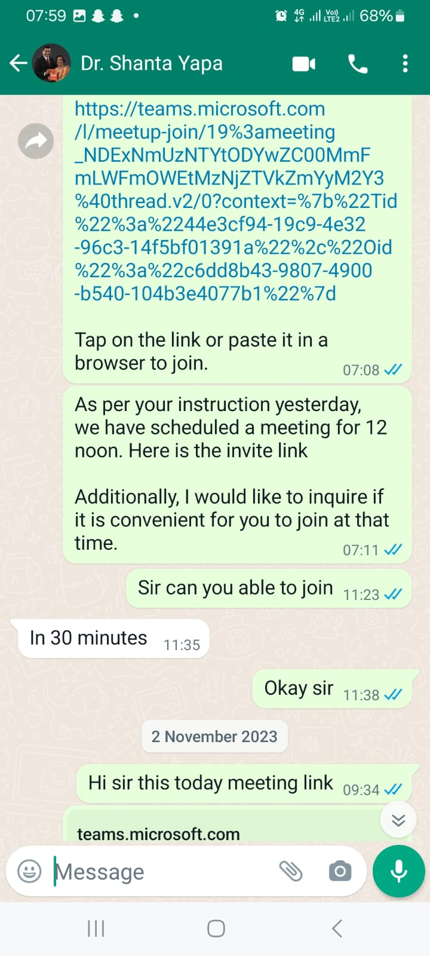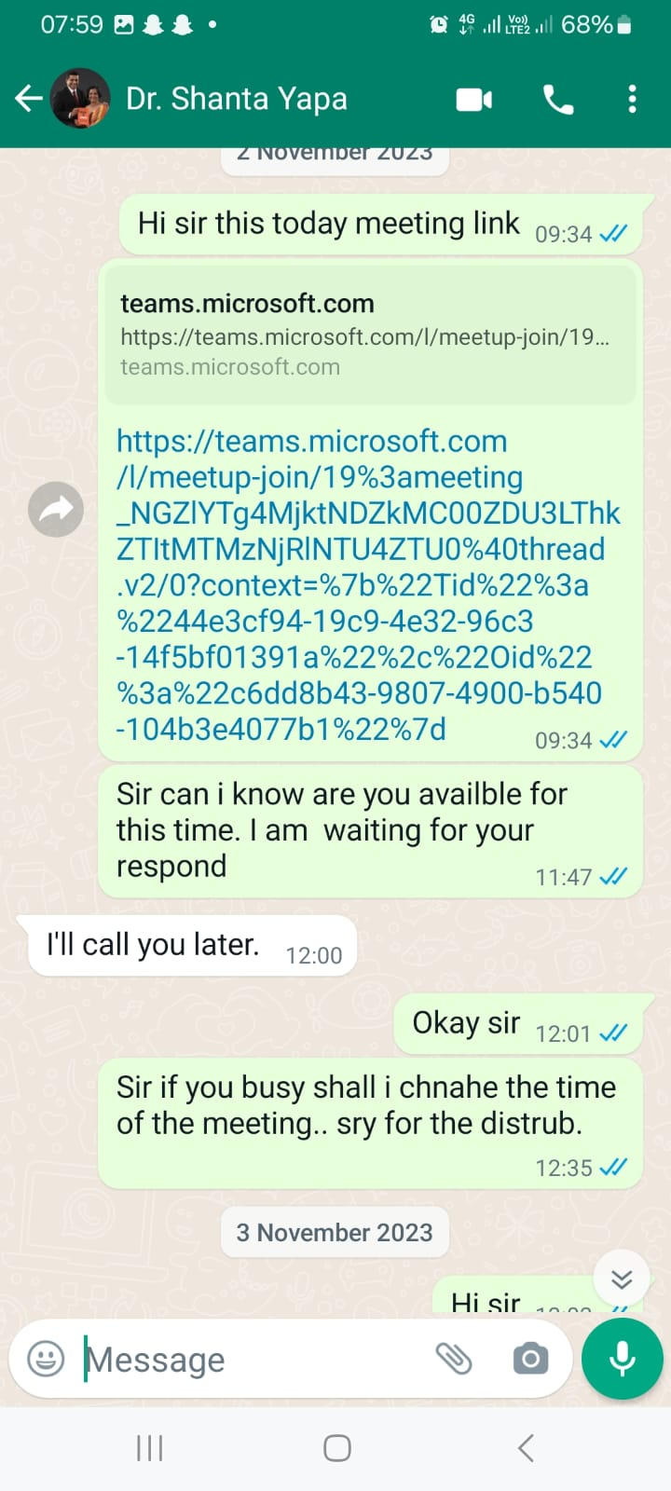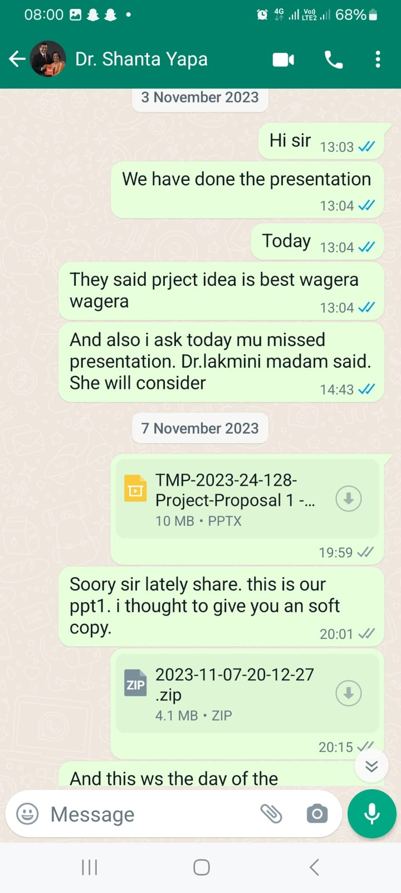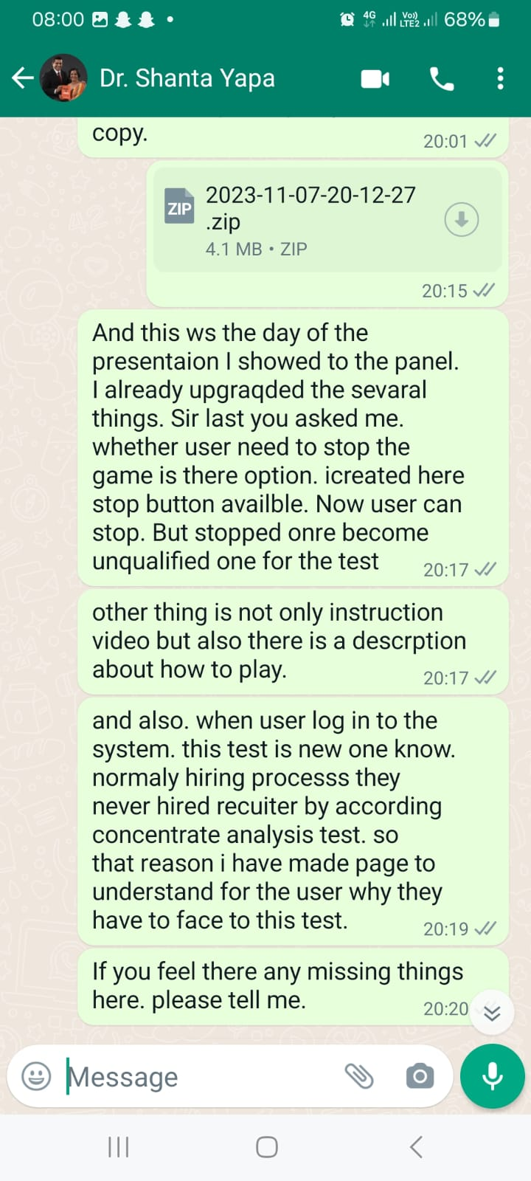

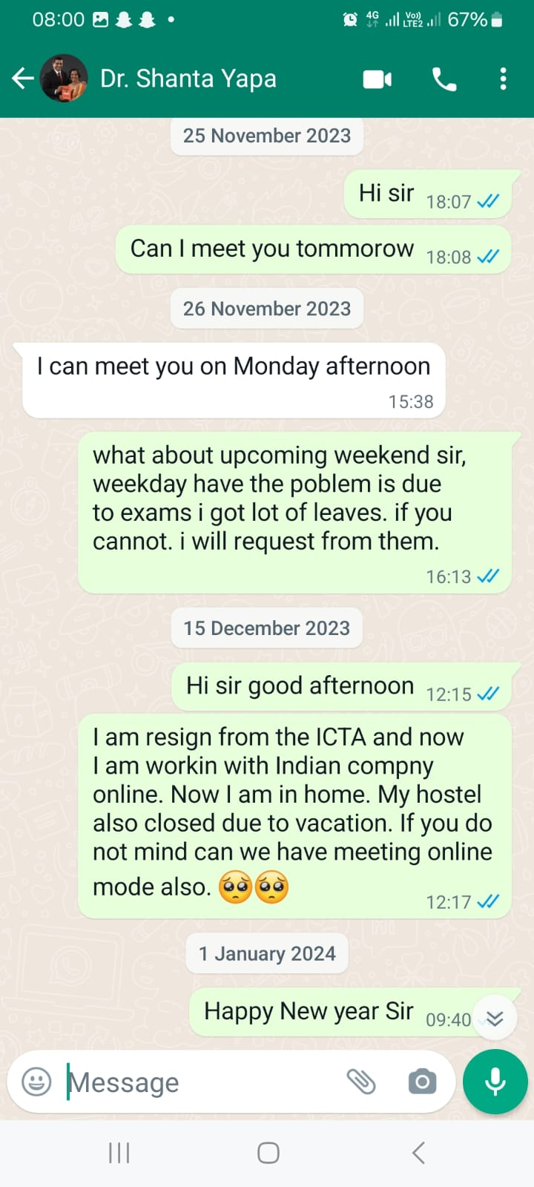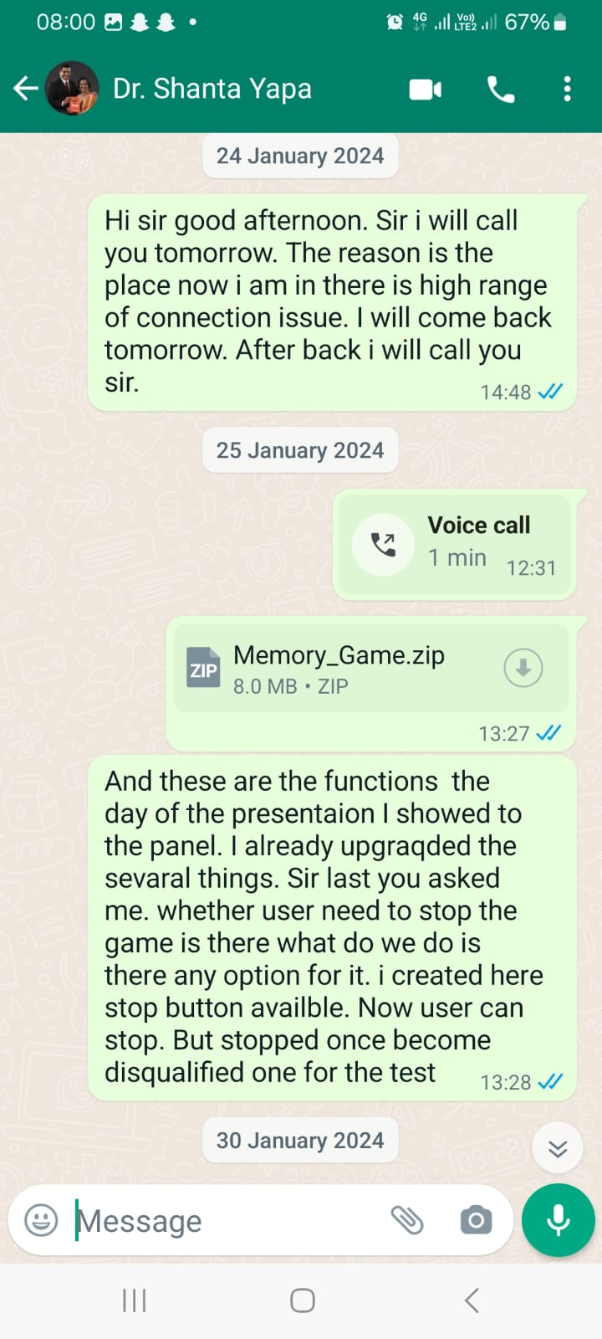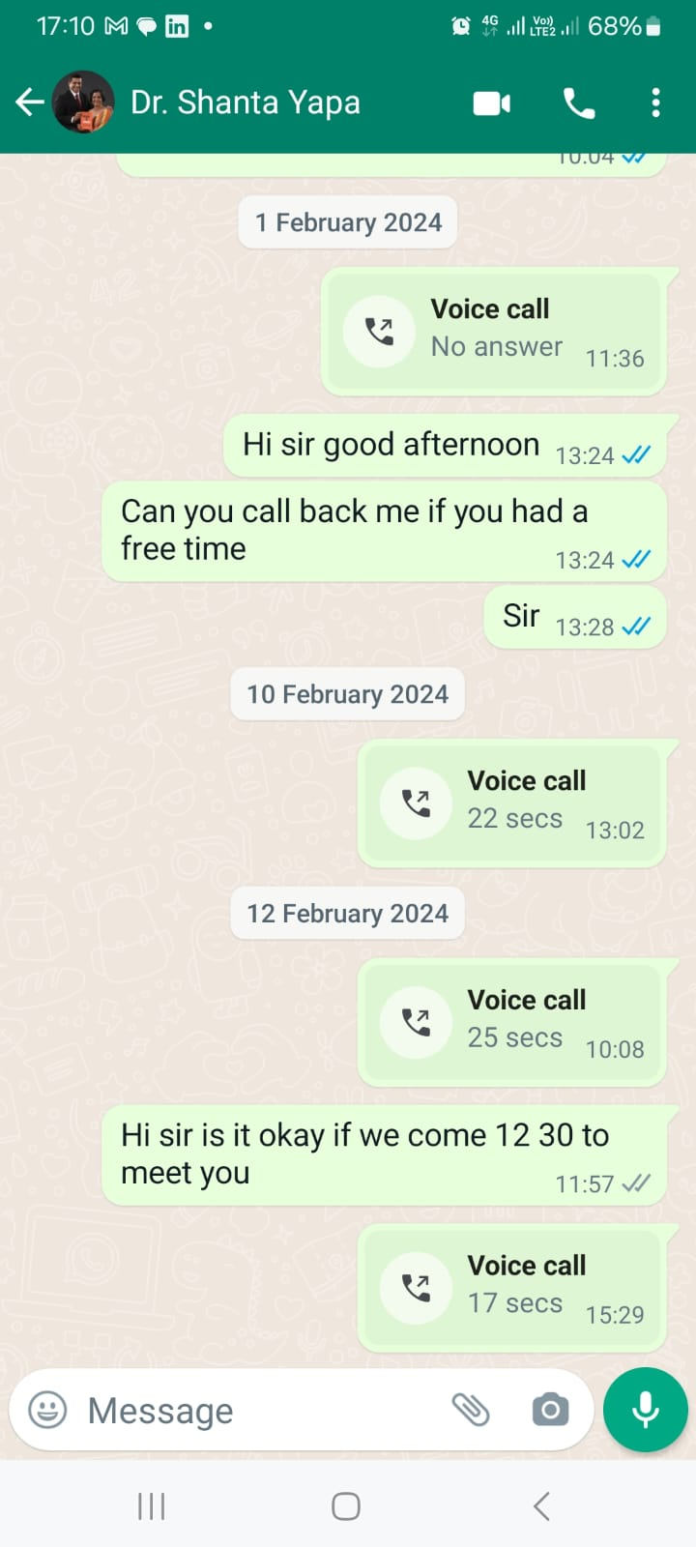

## Figure 02: Chats with Co-Supervisor

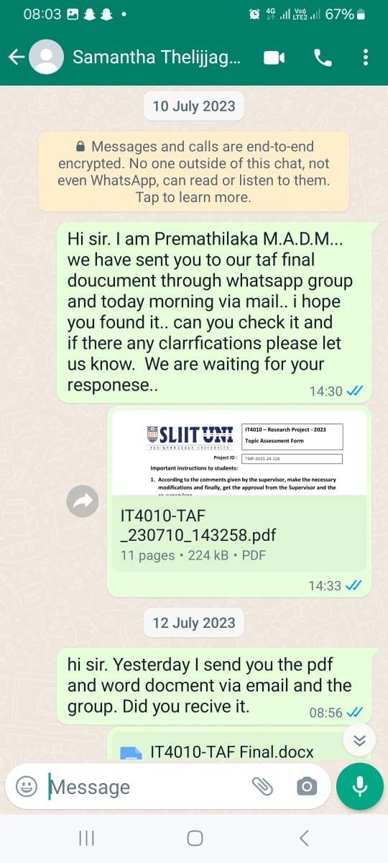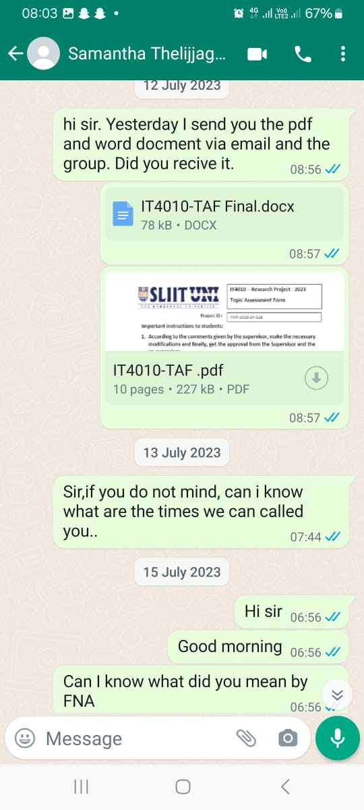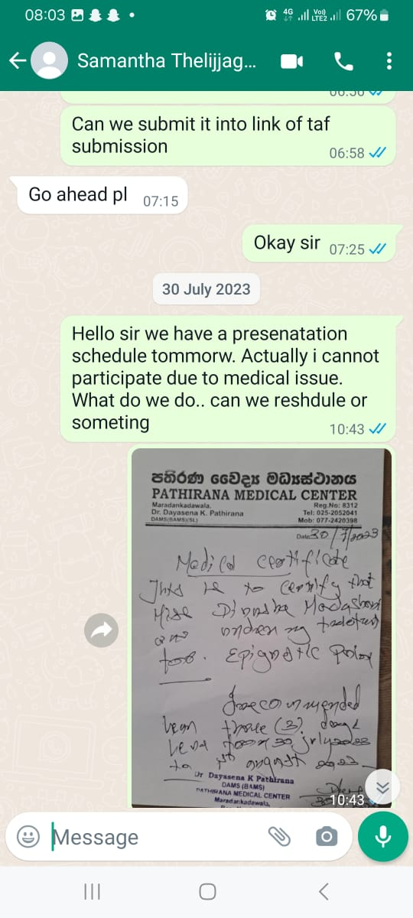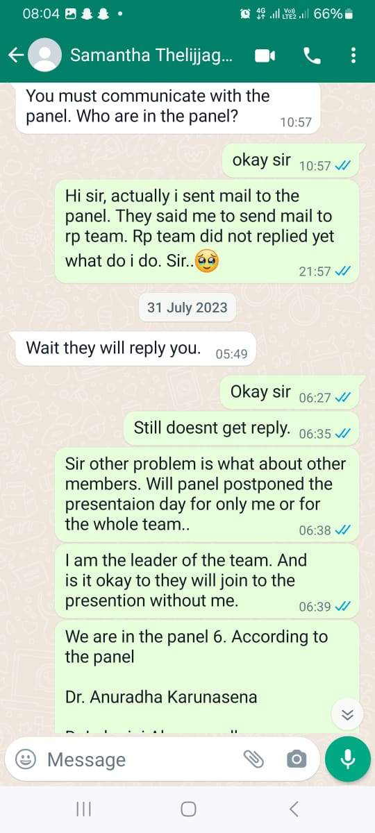

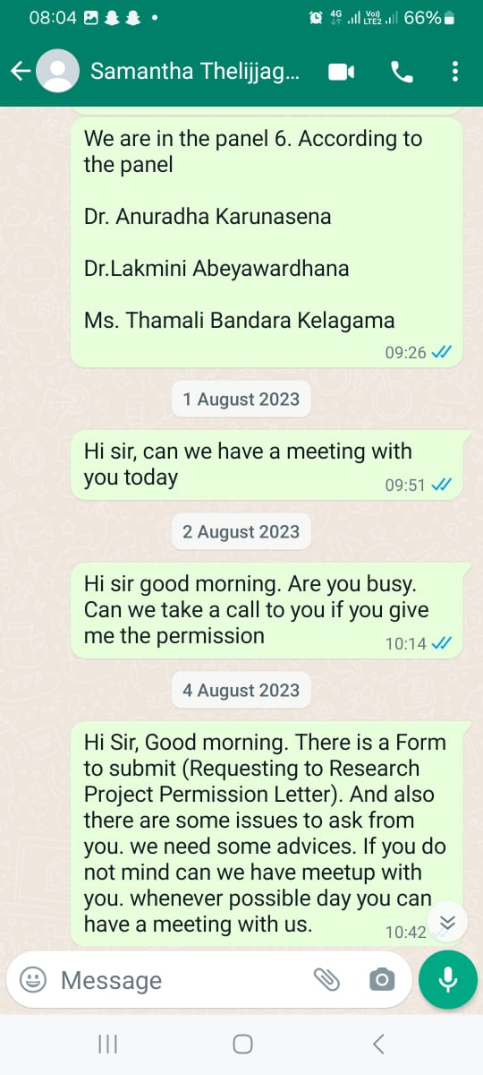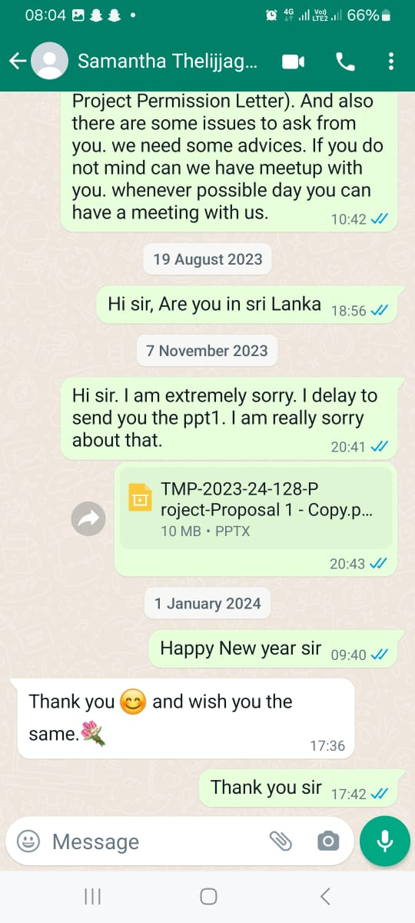

## Figure 03: Group Chats with Co-Supervisor

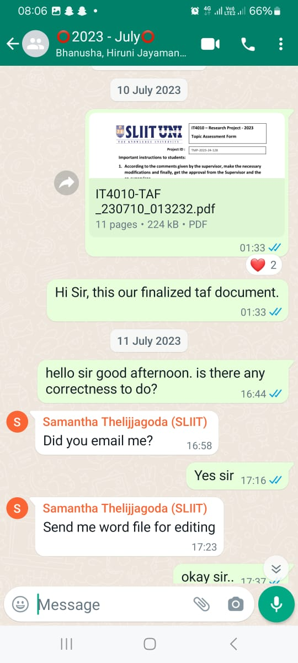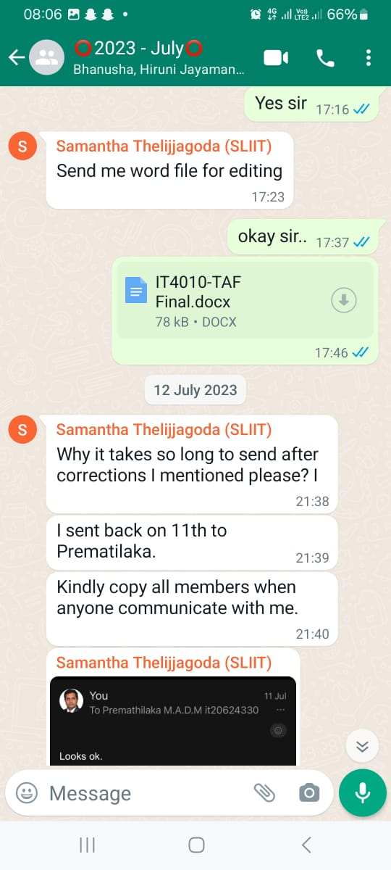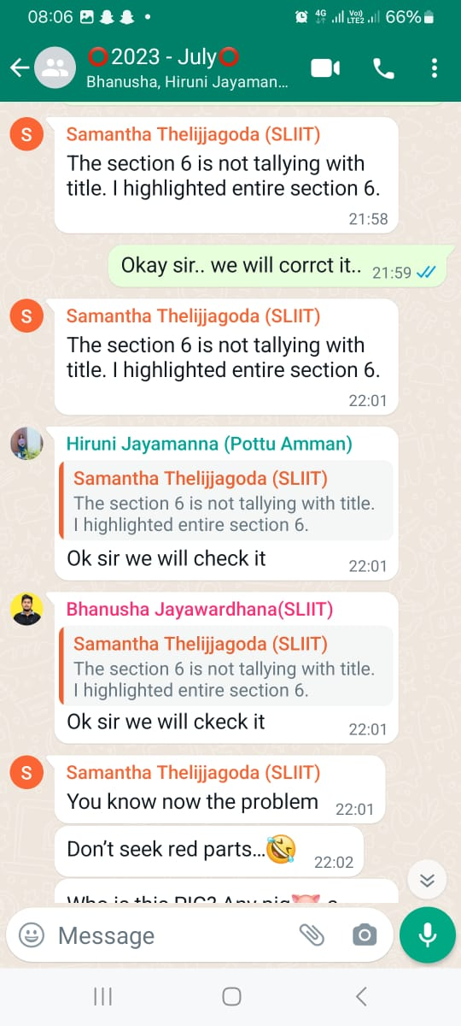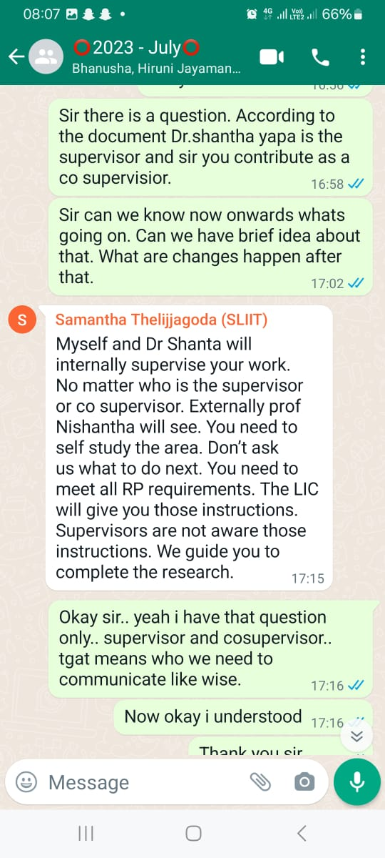

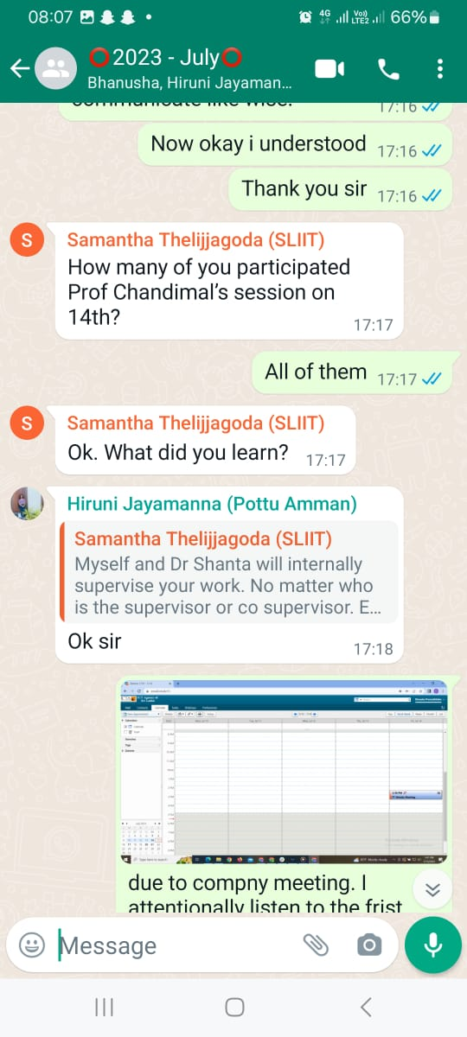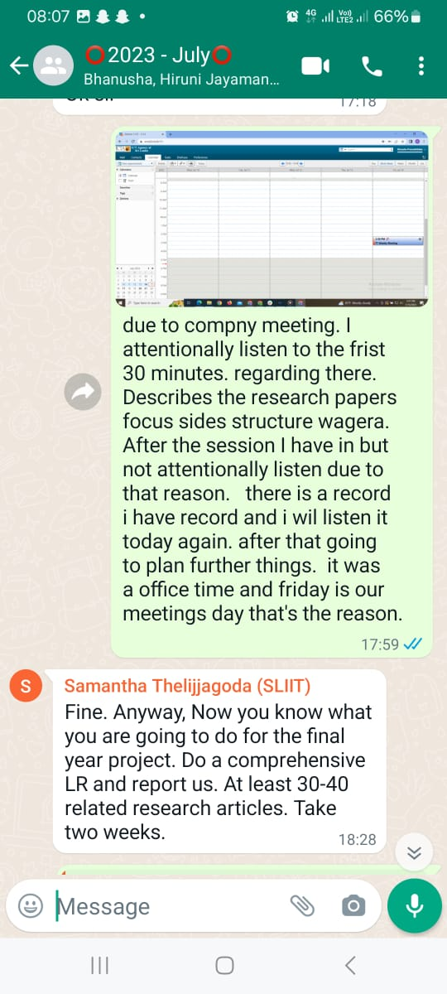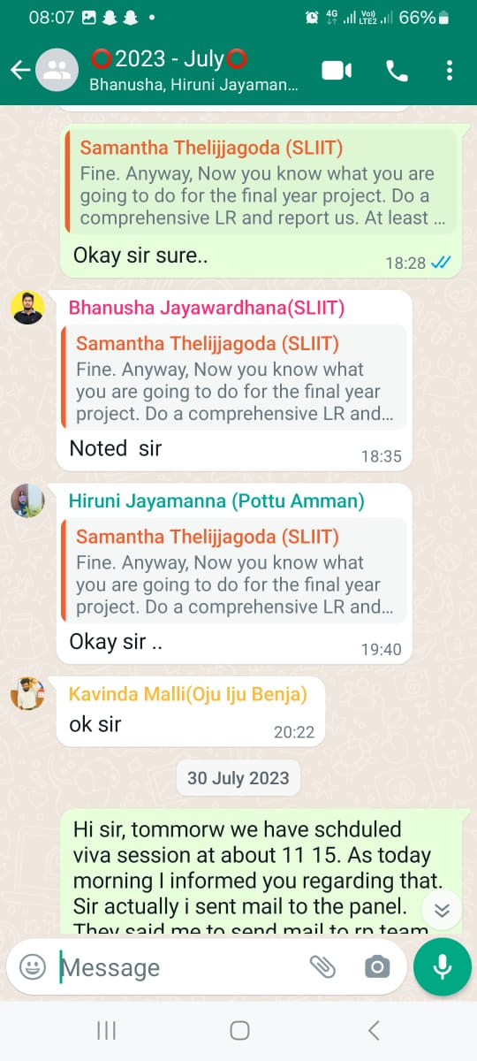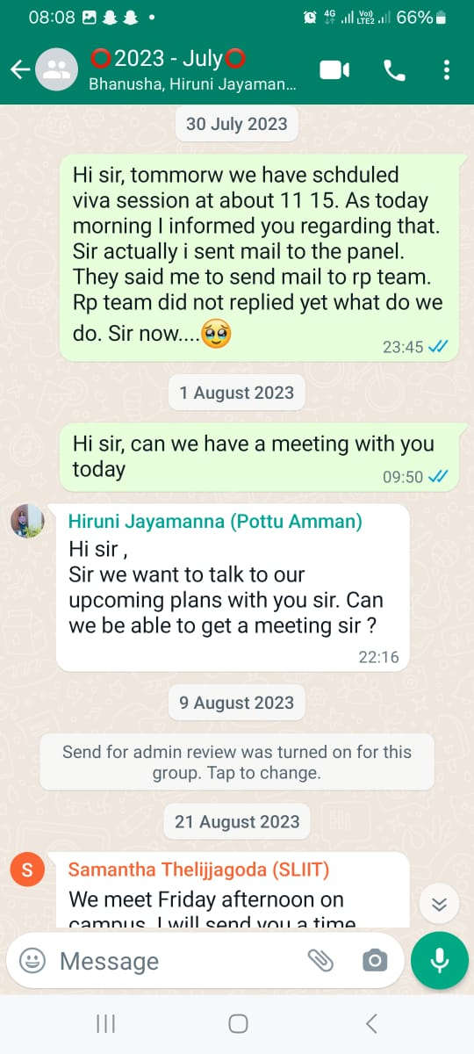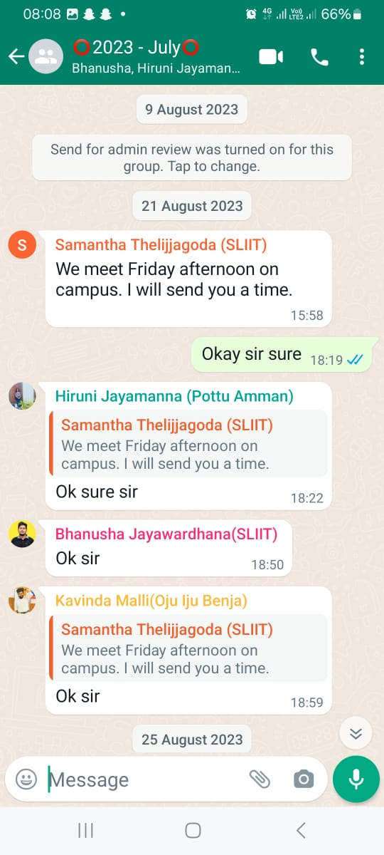

# Gantt Chart

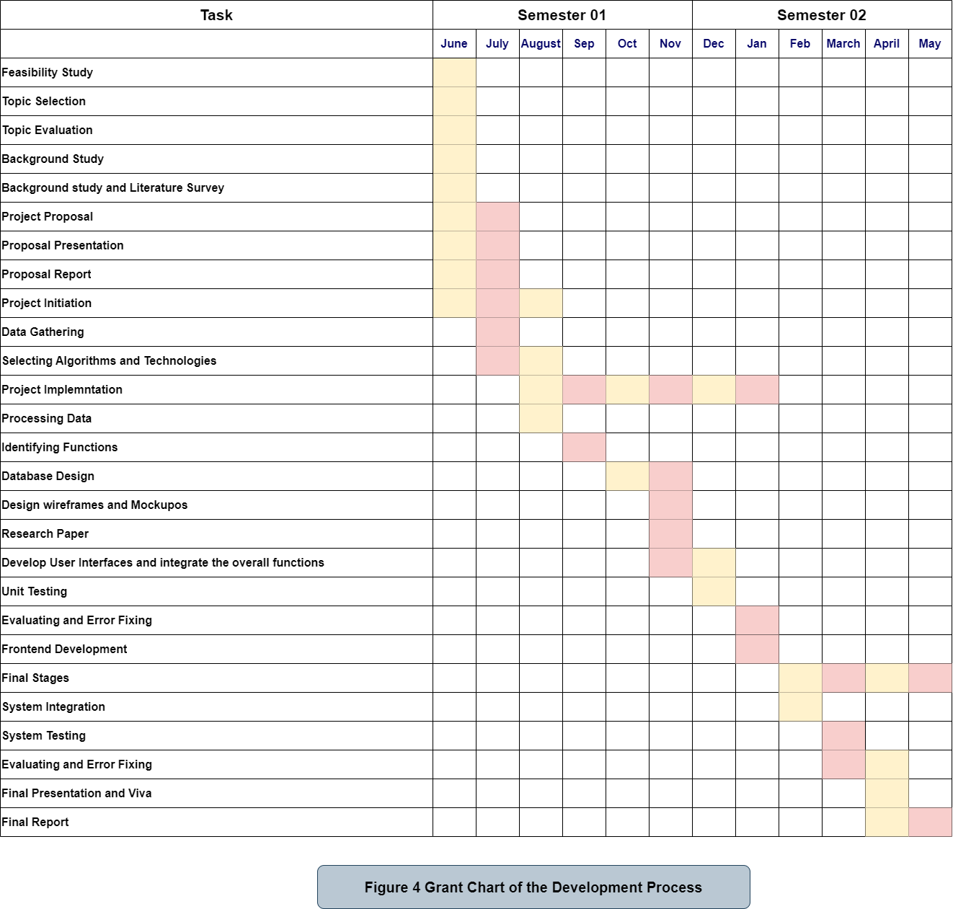

# Work Breakdown Structure

